Magnetic properties and structural characterization of iron oxide nanoparticles formed by Streptococcus suis Dpr and four mutants

Teemu Haikarainen, Petriina Paturi, Johan Lindén, Sauli Haataja, Wolfram Meyer-Klaucke, Jukka Finne and Anastassios C. Papageorgiou

Teemu Haikarainen • Anastassios C. Papageorgiou () Turku Centre for Biotechnology, University of Turku and Åbo Akademi University, Turku FI-20521, Finland. E-mail: tassos.papageorgiou@btk.fi
Petriina Paturi Wihuri Physical Laboratory, Department of Physics and Astronomy, University of Turku, FI-20014, Finland
Johan Lindén Physics Department, Åbo Akademi University, Turku FI-20500, Finland
Sauli Haataja Department of Medical Biochemistry and Genetics, University of Turku, Turku FI-20520, Finland
Wolfram Meyer-Klaucke EMBL, Hamburg outstation, Notkestrasse 85, D-22603, Germany
Jukka Finne Department of Biosciences, University of Helsinki, Helsinki FI-00014, Finland

Abbreviations
Dps, DNA-binding protein from starved cells
Dpr, Dps-like peroxide resistance protein
EXAFS, extended X-ray absorption fine structure
ICP-MS, inductively coupled plasma mass spectrometry
SQUID, superconducting quantum interference device
XANES, X-ray Absorption Near Edge Structure

Abstract
Streptococcus suis Dpr belongs to the Dps family of bacterial and archaeal proteins that oxidize Fe²⁺ to Fe³⁺ to protect microorganisms from oxidative damage. The oxidized iron is subsequently deposited as ferrihydrite inside a protein cavity resulting in the formation of an iron core. The size and the magnetic properties of the iron core have attracted considerable attention for nanotechnological applications in recent years. Here, the magnetic and structural properties of the iron core in wild-type Dpr and four cavity mutants were studied. All samples clearly demonstrated a superparamagnetic behaviour in SQUID magnetometry and Mössbauer spectroscopy compatible with that of superparamagnetic ferrihydrite nanoparticles. However, all the mutants exhibited higher magnetic moments than the wild-type protein. Furthermore, measurement of the iron content with inductively coupled plasma mass spectrometry revealed a smaller amount of iron in the iron cores of the mutants, suggesting that the mutations affect nucleation and iron deposition inside the cavity. The X-ray crystal structures of the mutants revealed no changes compared to the wild-type crystal structure, thus the differences in the magnetic moments could not be attributed to structural changes in the protein. EXAFS measurements showed that the coordination geometry of the iron cores of the mutants was similar to that of the wild-type protein. Taken together, these results suggest that mutation of the residues that surround the iron storage cavity could be exploited to selectively modify the magnetic properties of the iron core without affecting the structure of the protein and the geometry of the iron core.

Keywords: ferroxidase · ferritins · streptococcal · proteins · nanoparticles · magnetization

Introduction
In recent years, there has been an increasing interest in superparamagnetic nanoparticles for use in a range of applications, such as tissue repair, drug delivery, immunoassays and magnetic resonance imaging [1]. Nanoparticles can be produced in several ways, including co-precipitation, sol-gel reactions, hydrothermal and high-temperature reactions, and mineralization inside protein cages [2]. The advantage of using protein cages as nanoreactors is that the nanoparticle properties can be modified not only by chemical manipulation but also by protein engineering techniques. Ferritins have been used as a model nanoreactor for iron oxide nanoparticle formation owing to their function as iron storage proteins capable of storing up to 4500 iron atoms [3]. The iron nanoparticles produced by ferritins have essentially been found to be superparamagnetic [4], and their magnetic behavior varies depending on the source of the protein and the composition of the iron core (native/reconstituted, fully/partially loaded) [5]. However, the iron oxidizing agents O₂ or H₂O₂ do not affect the properties of the iron core in ferritin [6]. Although the composition of the iron core has usually been described as ferrihydrite, it has also been suggested to exhibit a multi-phase system of magnetite/haematite/ferrihydrite. Accordingly, the iron cores have been found to contain mainly ferrihydrite in their inner part with their surface composed of magnetite. Thus, larger cores of 1000-2000 iron atoms consist mostly of a ferrihydrite phase whereas smaller cores (< 500 iron atoms) have magnetite as the predominant phase [7].
Dps (DNA-binding protein from starved cells) proteins form homo-oligomeric spherical assemblies consisting of 12 subunits with a hollow spherical cavity in the middle. The cavity functions as iron storage able to accommodate up to 500 iron atoms [8]. Dps proteins protect the cell against hydroxyl radicals, which are extremely harmful for the organisms as they degenerate biomolecules, including DNA. The protection is achieved by ferroxidase activity where Fe²⁺ is oxidized to Fe³⁺ [9, 10]. This oxidation prevents Fe²⁺ from forming hydroxyl radicals with H₂O₂ according to Fenton reaction:
H₂O₂ + Fe²⁺ → Fe³⁺ + OH⁻ + OH·
The iron oxidation and mineralization process includes the oxidation of Fe²⁺ in the ferroxidase centers (FOCs), which are located at the dimer interfaces of Dps dodecamers. Twelve FOCs are present inside the spherical assembly. After oxidation, iron moves to the protein cavity, where nucleation and deposition of the ferrihydrite mineral takes place.
Several mutagenesis studies involving ferritins have been performed [11-13]. For example, mutations of three Glu residues to Ala at the ferritin cavity were found to reduce iron uptake rates without affecting the formation of a conventional mineral core [12]. Recently, a study of Escherichia coli Dps revealed that the protein remained stable even after extensive mutations in cavity residues [14]. The mutations, however, were found to have an effect on the iron nucleation/mineralization efficiency of the protein. A recent study of a wild-type and a FOC triple mutant of Listeria innocua Dps showed that the triple mutant has a reduced efficiency of iron mineralization, but the iron core retains its native structure [15]. As evidenced by sedimentation velocity and transmission electron microscopy, iron mineralizes in the protein cavity as maghemite/magnetite nanoparticles, exhibiting superparamagnetic behaviour in magnetic measurements with blocking temperatures of 4.5 K.
In this report, we have used the Streptococcus suis Dps-like peroxide resistance protein (SsDpr) to study the properties of the iron core in the wild-type protein and in four mutants (E64A, E67A, E68A and E75A). The mutated residues lie around the cavity and provide a negatively charged environment. The analysis of the iron cores by superconducting quantum interference device (SQUID) magnetometry and Mössbauer spectroscopy combined with X-ray absorption spectroscopy (XAS) allowed the determination of magnetic and structural properties of the cores. The results suggest that protein engineering targeting the cavity-lining residues could be employed to manipulate the iron core properties and to prepare novel nanoparticles with varied properties.
Materials and Methods
Site-directed mutagenesis
E64A, E67A, E68A, and E75A mutants were obtained by PCR using primers annealed back to back to the plasmid pSSUD2 (Supplementary information, Table 2) [24, 25]. PCR amplification was performed using Phusion hot start DNA polymerase. The products were circularized using Quick T4 DNA ligase (Finnzymes, Finland). The ligation mixture was used to transform NovaBlue cells. The mutated clones of pSSUD2 were sequenced with ABI PRISM 3130xl® Genetic Analyzer using the dye terminator method. The plasmids carrying the verified mutations were transformed into BL21(DE3) pLysS cells for protein expression.
Protein expression and purification
The protein expression was carried out in LB medium supplemented with chloramphenicol (30 µg ml⁻¹) and kanamycin (30 µg ml⁻¹). The cultures were grown at 310 K until OD₆₀₀ reached ~0.6 and subsequently induced with 1 mM IPTG at 303 K for 5 hours. The cells were collected by centrifugation (3000 x g, 20 minutes) and the pellets were shifted to 253 K for storage. The frozen pellets were suspended in lysis buffer (50 mM sodium phosphate, 300 mM NaCl, 5 mM imidazole) supplemented with 0.025 mg/ml DnaseI, 5 mM MgCl₂ and EDTA-free Complete protease-inhibitor cocktail (Roche) according to manufacturers instructions. The mixture was incubated on ice for 30 minutes. The cell lysis was completed with sonication and the cell debris was removed by centrifugation (31000 x g, 20 minutes). The cleared lysate was incubated with His-Select® HF Nickel Affinity Gel (Sigma-Aldrich) at room temperature for 30 minutes. The resin was applied into a gravity-flow column and washed with lysis buffer. The protein was eluted with 50 mM sodium phosphate, 300 mM NaCl, 250 mM imidazole. The buffer was changed to 20 mM Tris-HCl pH 8.0, 0.5 M NaCl in PD-10 column (Amersham Biosciences) and incubated with thrombin protease (Calbiochem) and 2.5 mM CaCl₂ for His₆-tag removal at room temperature overnight. The protein was further purified with gel filtration (HiPrep 26/60 Sephacryl S-300 HR) with 10 mM Tris-HCl pH 7.5, 150 mM NaCl.
Iron loading
The purified protein samples were loaded with natural iron in aerobic conditions [6]. The proteins (1 mg/ml) were mixed with 500 x molar excess of (NH₄)₂Fe(SO₄)₂ and after incubation on ice for one hour they were thoroughly dialyzed against the gel filtration buffer. The samples used in all the experiments were from the same batch.
ICP-MS measurements
The iron and phosphorus concentration measurements were performed by ICP-MS (Perkin-Elmer Elan 6100 DRC+) with masses Fe(56) and P(31). For mass 56, the dynamic reaction chamber (DRC) was used to eliminate ArO interference effect. All samples were measured 5 times.
Crystallographic data collection and processing
X-ray diffraction data were collected on beamline X12 at EMBL Hamburg, c/o DESY. The data were collected under nitrogen gas flow at cryogenic (100K) temperatures and processed with the XDS package [26] (E67A) or MOSFLM [27] / SCALA [28] (E64A, E68A and E75A). All crystals were found to belong to the orthorhombic P2₁2₁2₁ space group and contained 12 monomers in the asymmetric unit. The data processing statistics for all data sets are given as Supplementary information (Table 3).
Structure determination and refinement
Initial phases were obtained from the iron-free SsDpr crystal structure (pdb accession code 1UMN) [29]. Refinement was carried out using PHENIX [30]. Manual rebuilding of the structures was done with COOT [31]. Structural superpositions were carried out with SSM [32]. The structures were not fully refined, because no structural differences were observed when compared to the wild-type protein. The R_{free} values for the partially refined structures are 23.2 %, 22.0 %, 22.7 % and 23.7 % for E64A, E67A, E68A and E75A, respectively.
XAS data collection
The iron-loaded samples were supplemented with 20 % glycerol and concentrated to ~50 mg/ml. Samples of 25 μl in volume were transferred into plastic sample holders covered with polyimid windows, frozen in liquid nitrogen and kept at 4 K during the experiment. X-ray absorption spectra at the Fe K-edge were recorded in fluorescence mode at Wiggler station 7-3 (Stanford Synchrotron Radiation Lightsource, Menlo Park, CA, USA) equipped with a Si(220) double crystal monochromatic, a focusing mirror and a 30 element Ge solid-state fluorescence detector (Canberra). Dead-time correction was applied to the fluorescence signals and saturation effects could be excluded because the dead-time was always below 20 %. Energy axis of each scan was calibrated by a reference sample (Fe foil; absorption edge calibrated to 7112 eV). Scan averaging, normalization and data reduction were performed with the KEMP2 program [33, 34] using E₀(Fe)=7120 eV.
XAS data analysis
The pre-edge peak areas were analyzed with WinXAS [35]. The extended X-ray absorption fine structure (EXAFS) oscillations were analyzed with the DL_EXCURV package [36], and the κ³-weighted spectra were used. The number of oxygen ligands was fixed according to the pre-edge results. For Fe shells, the Debye-Waller factors were grouped according to distances to avoid over-interpretation of the data. The R-factors were used as a measure of the goodness of the fits. Ab initio theoretical phase and amplitude functions were generated. The experimental spectra were compared with the theoretical simulations. No Fourier filtering was applied.
Magnetic measurements
The protein samples were concentrated to ~25 mg/ml and freeze-dried prior to the measurements. The DC-magnetization measurements were performed in a SQUID magnetometer at temperatures of 5-80 K and in magnetic fields up to 6 T. The weighted samples were first zero-field cooled (ZFC) and then the magnetic field was increased to 10 mT and the temperature dependence of magnetization was measured. After reaching 80 K, the temperature was decreased and the field-cooled (FC) curve was recorded. The magnetization loops were measured at temperatures of 5 K, 20 K, 40 K and 80 K. The maximum magnetic field was 6 T.
The AC-magnetization measurements were performed in a Quantum Design Physical Property Measurement System (PPMS) with the ACMS option at temperatures of 1.9 K - 20 K. The DC magnetic field was zero, the AC-field amplitude was 1 mT and the magnetic field frequencies used were 100, 316, 1000, 3162 and 10000 Hz. The same samples were used as in the DC-magnetization measurements.
Mössbauer spectroscopy
The samples were prepared in the same way as those used for the magnetic measurements. The measurements were performed using a 25 mCi ⁵⁷Co:Rh source (Cyclotron Co., activated in Apr 2009) at fixed temperatures of 77 and 300 K in transmission geometry with a maximum Doppler velocity of 2.05 mm/s and with a few additional measurements of 10.0 mm/s to confirm the absence of magnetic ordering. The spectra were fitted using three spectral components defined by the following hyperfine parameters: the chemical isomer shift relative to α-Fe, the relative component intensities (I), the quadrupole coupling constants, and the resonance line width (Γ), which was constrained to be equal for all three components. The spectra were recorded between May 2009 and January 2010.
Results and Discussion
Iron and phosphorus content
The content of iron in the proteins was measured with inductively coupled plasma mass spectroscopy (ICP-MS). It was found that the wild-type SsDpr iron core has an iron content of approximately 290 iron atoms which is higher than that determined previously (180 iron atoms) [16]. This difference could be attributed to the optimization of the iron loading protocol by using a higher molar excess of iron (500x) than previously (1.5x). All the mutant proteins contained less iron than the wild-type SsDpr. E64A and E67A have about 50 iron atoms and E68A and E75A about 40 iron atoms less (Supplementary information, Table 1). The smaller number of incorporated iron atoms may be related to decreased iron nucleation efficiency due to the mutations. However, more evidence is needed to confirm this hypothesis. Because phosphorus has also been found in several ferritin and Dps cores, the amount of phosphorus was also verified with ICP-MS. In agreement with previous measurements of the wild-type SsDpr iron core, no significant amount of phosphorus was found in the present cores [16].
Overall crystal structures
The crystal structures of the mutant proteins were determined in order to study whether mutations had an effect on the overall structure of the protein, and especially on the integrity of the cavity. No structural changes were observed between the mutants and the wild-type protein as reflected also by the low root mean square deviations between the Cα positions of the wild-type and E64A, E67A, E68A and E75A (0.201 Å, 0.226 Å, 0.217 Å and 0.279 Å, respectively).
Geometry of the iron cores
The iron core geometries of the mutant proteins were determined with XAS. The pre-edge peaks were used to estimate the number of oxygen ligands in each core in the first coordination shell and the spectra were compared to the pre-edge spectra previously measured for wild-type SsDpr (Figure 1) [16]. The spectra superpose almost perfectly, indicating a similar coordination for iron in the cores. The pre-edge peaks correspond to quasi-forbidden 1s → 3d transition and shows structure related to the electronic structure of iron, specifically to the 3d manifold. The extended X-ray absorption fine structures (EXAFS) (up to 1000 eV for mutants E64A and E67A and 750 eV for mutants E68A and E75A) were then refined, which revealed almost identical Fe-Fe distances as in the wild-type SsDpr core (Table 1). The EXAFS spectrum for E68A and its Fourier transform are depicted in Figure 2. In agreement with the wild-type core, the spectra show a high amplitude at a low photoelectron wave vector k and small amplitude at high k. This indicates the presence of light ligands (in this case oxygen) in the first shell and a strong component (e.g. heavy scatterer) in the farther shell (here, iron). The first oxygen shell could be explained by the presence of five to six oxygen atoms according to the pre-edge data. The best fits were obtained by refining 5.5 oxygen atoms in the first shell. This corresponds to the structure of ferrihydrite, which in its ideal form consists of 20 % FeO₄ and 80 % FeO₆ polyhedra [17]. The refinement of the shells considering a phosphate contribution to the scattering also produced good fits, but decreased the coordination number of iron considerably. These fits were excluded based on the high amount of iron and minimal amount of phosphate in the cores according to ICP-MS measurements. The best fits were obtained when iron was refined in three shells with distances similar to the wild-type core. The geometry of the iron cores in the mutant proteins also corresponds well to that of the typical ferrihydrite iron core found in ferritins [18, 19].
Magnetic measurements
The wild-type SsDpr and the mutant proteins were analyzed with SQUID magnetometry. All samples showed clear superparamagnetism with blocking temperature below 5 K in DC-measurements. Accordingly, the ZFC and FC curves did not deviate from each other. The magnetic moment of each particle was determined independently from both the magnetization loops and the temperature dependency of the susceptibility. The hysteresis loop of a superparamagnetic sample follows the Langevin function
$M\left(B,T\right)=Nμ\left[\text{coth}\left(\frac{μB}{k_{B}T}\right)−\frac{k_{B}T}{μB}\right],$ (1)
where M is the apparent magnetization, N is the number of particles per unit volume, μ is the magnetic moment of an individual particle, B is the magnetic field density, k_{B} is the Boltzmann constant and T is the temperature [20]. Since the number of particles is known from the known weights of the sample and the molecular weight of the protein, μ can be determined by fitting the function to the measured magnetization. An example of the fitting is shown in the inset of Figure 3 for E68A sample. The 40 K hysteresis loop was used for fitting. The 5 K loop does not scale well with the others, since it is so close to the blocking temperature. For other samples, the magnetic moment values from the fittings are shown in Table 2. The magnetic moment of the particles can also be determined from the temperature dependence of the susceptibility. The susceptibility χ(B,T) of superparamagnetic samples follows
$χ(B,T)μ_{0}=\frac{∂M\left(B,T\right)}{∂B}=μ_{0}Nμ\left[\left[1−{\text{coth}}^{2}\frac{μB}{k_{B}T}\right]\left(\frac{μ}{k_{B}T}\right)+\frac{k_{B}T}{{μB}^{2}}\right],$ (2)
where μ₀ is the permeability of free space [20]. This can be fitted to the ZFC and FC curves shown in Figure 3. The obtained magnetic moment μ is slightly higher for all the samples than the value obtained from the hysteresis loop, but the difference is not large. The magnetic moments of all the samples are listed in Table 2. The obtained magnetic moment values agree very well with the antiferromagnetic ordering of ferrihydrite. As can be seen, the iron cores of the mutants do not differ from each other appreciably but the iron core of the native protein has about 5-10 μ_{B} smaller moment per particle. The presence of less iron atoms in the iron core of the mutants suggests a higher surface/volume ratio for the core that could increase the number of unpaired spins on the surface of the iron core, resulting in higher magnetic moment.
Using AC-magnetization measurements, the frequency dependence of the blocking temperature was determined. The blocking temperature T_{B} is defined as the maximum in the temperature dependence of magnetization. T_{B} increases with increasing frequency since at high frequency the magnetic moments of the particles have less time to reach the thermal equilibrium, which shows as the paramagnetic-like 1/T-curve at high temperatures. The AC-magnetization of the E68A sample is shown in Figure 4, the inset shows the frequency dependence of T_{B}. The T_{B} depends on the magnetic anisotropy energy U_{eff} [21, 22] as
$T_{B}=\frac{U_{\text{eff}}V}{\text{ln}\left(f/{f_{0}}\right)},$ (3)
where V is the particle volume, f is the characteristic frequency of the measurement (AC-field frequency in this case) and f₀ is the attempt frequency. By fitting the Eq. (3) to the data we get U_{eff} and f₀ (Table 2). The blocking temperature of the samples varies with measurement frequency as expected for superparamagnetic samples. Accordingly, no differences are observed in attempt frequency or magnetic anisotropy energy in the samples.
Mössbauer spectroscopy
Identical paramagnetic Mössbauer spectra were obtained for the wild-type and the four mutants at 300 K. Cooling the samples down to 77 K did not cause any magnetic splitting of the resonance lines. Fitting the spectra using three spectral components resulted in χ² values close to 1.0 and experimental line widths of the order of 0.37 mm/s (Figure 5). The asymmetry of the Mössbauer spectra was modeled using a singlet line close to zero velocity, whereas the two doublet components are centered around 0.2-0.3 mm/s, which is typical for high-spin Fe³⁺, found e.g. in iron oxides. The non-zero quadrupole coupling constant for these components is compatible with superparamagnetic ferrihydrite particles [23]. The singlet covers ~6 % of the total intensity of the Mössbauer spectra, i.e. it corresponds to just ~15 Fe atoms, when the two doublets are assigned to the iron core of 240 Fe atoms. The presence of 240 iron atoms in the core corresponds to an average diameter of ~23 Å, close to the 30 Å found for Listeria innocua Dps mineral core [15]. Considering that there are 12 Fe atoms coordinated to the ferroxidase center of the proteins outside the iron core, the singlet probably originates from these external Fe atoms (Table 3). This is further supported by its differing isomer shift, as the chemical environment is different from the oxygen-coordinated core atoms. An isomer shift close to zero velocity is hard to be assigned to a specific oxidation state. For instance, it could be a low-spin Fe³⁺, a zero-spin Fe²⁺ or even Fe⁴⁺; however, given the chemistry of the present samples and the XAS edge position and shape, Fe⁴⁺ is highly unlikely.
According to the EXAFS results, the average coordination number for iron is between 5 and 6. These two coordinations are both compatible with the Fe³⁺ state, but they should exhibit distinct quadrupole coupling constants. Precise numbers cannot be given as the exact location of the Fe³⁺ atoms inside the coordination polyhedra is unknown. Assuming that the five-coordinated atom gives a higher quadrupole splitting, the average coordination numbers for the four mutant samples at 300 K and at 77 K are presented in Table 4.
Alternatively [6], the two components may be simply connected to the surface-layer and bulk atoms, respectively. With a cluster size of 240 iron atoms, approximately 143 of them are in the outermost layer and 101 in the bulk. This would give a bulk-to-surface ratio of 97:143 or 0.67. Indeed, the intensity ratio of the two Mössbauer components for all the samples was 0.60-0.90, i.e. of similar magnitude (Table 5).
Conclusion
The effect of point mutations on the magnetic and structural properties of the iron oxide core formed in SsDpr was studied. It was found that the iron core of the mutants contained less iron compared to the wild-type SsDpr, suggesting that the mutations affect the nucleation and deposition of iron inside the cavity. The iron core of the mutants has a similar geometry as that of the wild-type, i.e. it consists of ferrihydrite, as observed for several other Dps proteins and ferritins. The magnetization measurements showed that while all the samples exhibited clear superparamagnetic behaviour, the magnetic moment of the mutants was consistently higher than that of the wild-type protein. Based on the crystal structures, this did not result from structural changes in the protein, but it can be explained by the smaller core size of the mutants, which leads to a higher surface/volume ratio for the cores and higher magnetic moments. The iron-iron distances in the mutant cores were similar to the wild-type iron core, indicating that the mutations did not have any significant effect on the coordination of the iron oxide nanoparticle. Systematic mutations of the cavity-lining residues could open new prospects in the manipulation of nanosized magnetic particles and the understanding of magnetism in biological systems. Further work is currently underway.
Acknowledgements
This work was supported by the Academy of Finland (grant number 121278 and 114100) and Turku University Foundation. The authors are grateful to SSRL for providing beamtime and to Erik Nelson and colleagues for their excellent support during the beamtime. We also thank Paul Ek for the ICP-MS measurements. Access to EMBL Hamburg (c/o DESY) was provided by the European Community's Seventh Framework Programme (FP7/2007-2013) under grant agreement no. 226716.

References
1. Gupta AK, Gupta M (2005) Biomaterials 26:3995-4021 DOI S0142-9612(04)00931-7 [pii] 10.1016/j.biomaterials.2004.10.012
2. Laurent S, Forge D, Port M, Roch A, Robic C, Vander Elst L, Muller RN (2008) Chem Rev 108:2064-2110 DOI 10.1021/cr068445e
3. Uchida M, Kang S, Reichhardt C, Harlen K, Douglas T (2010) Biochim Biophys Acta 1800:834-845 DOI S0304-4165(09)00340-7 [pii] 10.1016/j.bbagen.2009.12.005
4. Papaefthymiou G (2010) Biochim Biophys Acta 1800:886-897 DOI S0304-4165(10)00092-9 [pii] 10.1016/j.bbagen.2010.03.018
5. Michel FM, Hosein HA, Hausner DB, Debnath S, Parise JB, Strongin DR (2010) Biochim Biophys Acta 1800:871-885 DOI S0304-4165(10)00140-6 [pii] 10.1016/j.bbagen.2010.05.007
6. Bou-Abdallah F, Carney E, Chasteen ND, Arosio P, Viescas AJ, Papaefthymiou GC (2007) Biophys Chem 130:114-121 DOI S0301-4622(07)00195-0 [pii] 10.1016/j.bpc.2007.08.003
7. Galvez N, Fernandez B, Sanchez P, Cuesta R, Ceolin M, Clemente-Leon M, Trasobares S, Lopez-Haro M, Calvino JJ, Stephan O, Dominguez-Vera JM (2008) J Am Chem Soc 130:8062-8068 DOI 10.1021/ja800492z
8. Bozzi M, Mignogna G, Stefanini S, Barra D, Longhi C, Valenti P, Chiancone E (1997) J Biol Chem 272:3259-3265
9. Haikarainen T, Papageorgiou AC (2010) Cell Mol Life Sci 67:341-351 DOI 10.1007/s00018-009-0168-2
10. Chiancone E, Ceci P (2010) Biochim Biophys Acta 1800:798-805 DOI S0304-4165(10)00018-8 [pii] 10.1016/j.bbagen.2010.01.013
11. Kilic MA, Spiro S, Moore GR (2003) Protein Sci 12:1663-1674 DOI 10.1110/ps.0301903
12. Wade VJ, Levi S, Arosio P, Treffry A, Harrison PM, Mann S (1991) J Mol Biol 221:1443-1452 DOI 0022-2836(91)90944-2 [pii]
13. Santambrogio P, Pinto P, Levi S, Cozzi A, Rovida E, Albertini A, Artymiuk P, Harrison PM, Arosio P (1997) Biochem J 322 ( Pt 2):461-468
14. Swift J, Wehbi WA, Kelly BD, Stowell XF, Saven JG, Dmochowski IJ (2006) J Am Chem Soc 128:6611-6619 DOI 10.1021/ja057069x
15. Ceci P, Chiancone E, Kasyutich O, Bellapadrona G, Castelli L, Fittipaldi M, Gatteschi D, Innocenti C, Sangregorio C (2010) Chemistry 16:709-717 DOI 10.1002/chem.200901138
16. Kauko A, Pulliainen AT, Haataja S, Meyer-Klaucke W, Finne J, Papageorgiou AC (2006) J Mol Biol 364:97-109 DOI S0022-2836(06)01114-4 [pii]
10.1016/j.jmb.2006.08.061 [doi]
17. Michel FM, Ehm L, Antao SM, Lee PL, Chupas PJ, Liu G, Strongin DR, Schoonen MA, Phillips BL, Parise JB (2007) Science 316:1726-1729 DOI 1142525 [pii]
10.1126/science.1142525
18. Nichol H, Gakh O, O'Neill HA, Pickering IJ, Isaya G, George GN (2003) Biochemistry 42:5971-5976 DOI 10.1021/bi027021l
19. Rohrer JS, Islam QT, Watt GD, Sayers DE, Theil EC (1990) Biochemistry 29:259-264
20. Hesse J, Bremers H, Hupe O, Veith M, Fritscher EW, Valtchev K (2000) J Magn Magn Mater 212:153-167
21. Guertin RP, Harrison N, Zhou ZX, McCall S, Drymiotis F (2007) J Magn Magn Mater 308:97-100
22. Gittleman J, I., Abeles B, Bozowski S (1974) Phys Rev B 9:3891-3897
23. Kundig W, Bommel H, Constabaris G, Lindquist RH (1966) Phys. Rev. 142:327-333
24. Haataja S, Penttinen A, Pulliainen AT, Tikkanen K, Finne J, Papageorgiou AC (2002) Acta Crystallogr D Biol Crystallogr 58:1851-1853 DOI S0907444902012970 [pii]
25. Pulliainen AT, Kauko A, Haataja S, Papageorgiou AC, Finne J (2005) Mol Microbiol 57:1086-1100 DOI MMI4756 [pii]
10.1111/j.1365-2958.2005.04756.x
26. Kabsch W (2010) Acta Crystallogr D Biol Crystallogr 66:125-132 DOI S0907444909047337 [pii]
10.1107/S0907444909047337
27. Leslie AG (2006) Acta Crystallogr D Biol Crystallogr 62:48-57 DOI S0907444905039107 [pii]
10.1107/S0907444905039107 [doi]
28. Collaborative Computational Project N (1994) Acta Crystallogr D Biol Crystallogr 50:760-763
29. Kauko A, Haataja S, Pulliainen AT, Finne J, Papageorgiou AC (2004) J Mol Biol 338:547-558
30. Adams PD, Grosse-Kunstleve RW, Hung LW, Ioerger TR, McCoy AJ, Moriarty NW, Read RJ, Sacchettini JC, Sauter NK, Terwilliger TC (2002) Acta Crystallogr D Biol Crystallogr 58:1948-1954 DOI S0907444902016657 [pii]
31. Emsley P, Cowtan K (2004) Acta Crystallogr D Biol Crystallogr 60:2126-2132 DOI S0907444904019158 [pii]
10.1107/S0907444904019158 [doi]
32. Krissinel E, Henrick K (2004) Acta Crystallogr D Biol Crystallogr 60:2256-2268 DOI 10.1107/s0907444904026460
33. Korbas M, Marsa D, F., Meyer-Klaucke W (2006) Review of Scientific Instruments 77:063105
34. Wellenreuther G, Meyer-Klaucke W (2009) J. Phys.: Conf. Ser. 190:1-4
35. Ressler T (1998) J Synchrotron Radiat 5:118-122 DOI S0909049597019298 [pii]
10.1107/s0909049597019298
36. Tomic S, Searle BG, Wander A, Harrison NM, Dent AJ, Mosselmans JFW, Inglesfield JE (2005) CCLRC Technical Report DL-TR-2005-001:ISSN 1362-0207

Figure legends
Figure 1. X-ray Absorption Near Edge Structure (XANES) spectra comparison of the SsDpr mutants with the wild-type protein.
Figure 2. EXAFS spectra and Fourier transform of E68A iron core. The continuous lines show the experimental data and the broken lines depict the best fits. (top) EXAFS spectra, (bottom) Fourier transform.
Figure 3. ZFC and FC magnetic susceptibility for E68A as a function of temperature. The solid line is a fit to Eq. (2). The inset shows magnetisation of the same sample as a function of magnetic field at temperatures 5 K, 20 K, 40 K and 80 K. The solid line is a fit to Eq. (1) at 40 K.
Figure 4. The real part (M′) of the AC-magnetisation of E68A at temperature range 1.9 K-20 K and at different magnetic field frequencies. The inset shows the dependence of the blocking temperature on measurement frequency and the fit to Eq. (3).
Figure 5. Fitted Mössbauer spectrum of E68A recorded at 77 K. Components used in the fit are: external Fe (blue singlet), surface layer Fe atoms (red quadrupole doublet) and bulk Fe atoms (green quadrupole doublet).

Table 1. EXAFS curve-fitting results.#
 | N | r (Å) | σ² (Å²) | E_{f} (eV)
Wilde-type SsDpr [16] |  |  |  | -6.3 ± 0.3
Fe-O | 5.0 | 1.99 ± 0.01 | 0.010 ± 0.001
Fe-Fe | 0.9 ± 0.3 | 2.86 ± 0.02 | 0.012 ± 0.002
Fe-Fe | 3.8 ± 0.9 | 3.07 ± 0.01 | 0.012 ± 0.002
Fe-Fe | 1.1 ± 0.6 | 3.41 ± 0.02 | 0.012 ± 0.002
E64A |  |  |  | -6.5 ± 0.5
Fe-O | 5.5 | 1.97 ± 0.01 | 0.011 ± 0.001
Fe-Fe | 0.7 ± 0.5 | 2.89 ± 0.06 | 0.008 ± 0.011
Fe-Fe | 2.1 ± 1.1 | 3.05 ± 0.04 | 0.008 ± 0.011
Fe-Fe | 1.0 ± 0.7 | 3.44 ± 0.03 | 0.008 ± 0.011
E67A |  |  |  | -6.5 ± 0.5
Fe-O | 5.5 | 1.98 ± 0.01 | 0.011 ± 0.001
Fe-Fe | 1.0 ± 0.5 | 2.94 ± 0.03 | 0.006 ± 0.009
Fe-Fe | 1.9 ± 1.2 | 3.08 ± 0.02 | 0.006 ± 0.009
Fe-Fe | 0.9 ± 0.9 | 3.42 ± 0.03 | 0.006 ± 0.009
E68A |  |  |  | -6.5 ± 0.5
Fe-O | 5.5 | 1.98 ± 0.01 | 0.011 ± 0.001
Fe-Fe | 0.7 ± 0.3 | 2.88 ± 0.04 | 0.007 ± 0.007
Fe-Fe | 2.2 ± 1.0 | 3.06 ± 0.01 | 0.007 ± 0.007
Fe-Fe | 0.6 ± 0.4 | 3.45 ± 0.04 | 0.007 ± 0.007
E75A |  |  |  | -6.5 ± 0.5
Fe-O | 5.5 | 1.98 ± 0.01 | 0.011 ± 0.001
Fe-Fe | 0.7 ± 0.3 | 2.89 ± 0.04 | 0.006 ± 0.009
Fe-Fe | 2.0 ± 1.1 | 3.06 ± 0.01 | 0.006 ± 0.009
Fe-Fe | 0.7 ± 0.5 | 3.44 ± 0.03 | 0.006 ± 0.009
# N, the coordination number; r, the mean interatomic distance; σ, the Debye-Waller factor; E_{f}, the Fermi energy offset. A combined σ was used for Fe-Fe and N was determined independently for each shell. Energy range for the refinements of E64A, E67A, E68A and E75A were 12-975 eV, 12-981 eV, 12-736 eV and 12-747 eV, respectively.

Table 2. Magnetic moments, anisotropy energy, and attempt frequency determined from the magnetization measurements.

Sample | μ from hysteresis | μ from ZFC | U_{eff} | f₀
 | (μ_{B})# | (μ_{B}) | (K) | (THz)
Wild-type SsDpr | 16.5 | 19.8 | 103 | 0.9
E64A | 24.3 | 29.4 | 112 | 0.9
E67A | 23.0 | 30.6 | 105 | 0.9
E68A | 23.3 | 29.1 | 110 | 0.9
E75A | 21.7 | 28.3 | 113 | 0.9

# Bohr magneton (9.274 x 10⁻²⁴ Am²).

Table 3. Singlet intensity and the corresponding number of iron atoms at 300 K and 77 K.

Sample# | Singlet intensity (%) |  | Number of iron aroms
Sample# | 300 K | 77 K | 300 K | 77 K
Wild-type SsDpr | 7.22 | - | 14 | -
E64A | 5.43 | - | 10.3 | -
E67A | 6.13 | - | 11.8 | -
E68A | 5.40 | 5.19 | 10.3 | 10.5
E75A | 7.70 | 5.18 | 15.0 | 9.8

# Only a few samples were measured at 77 K in order to confirm the absence of magnetic splitting.

Table 4. Coordination numbers for iron at 300 K and 77 K by Mössbauer spectroscopy.

Sample | Coordination number
Sample | 300 K | 77 K
Wild-type SsDpr | 5.56 | -
E64A | 5.60 | -
E67A | 5.61 | -
E68A | 5.57 | 5.66
E75A | 5.52 | 5.63

Table 5. Bulk-to-surface intensity ratios at 300 K and 77 K.

 | Intensity ratio
Sample | 300 K | 77 K
E64A | 0.60 | -
E67A | 0.64 | -
E68A | 0.77 | 0.52
E75A | 0.91 | 0.59

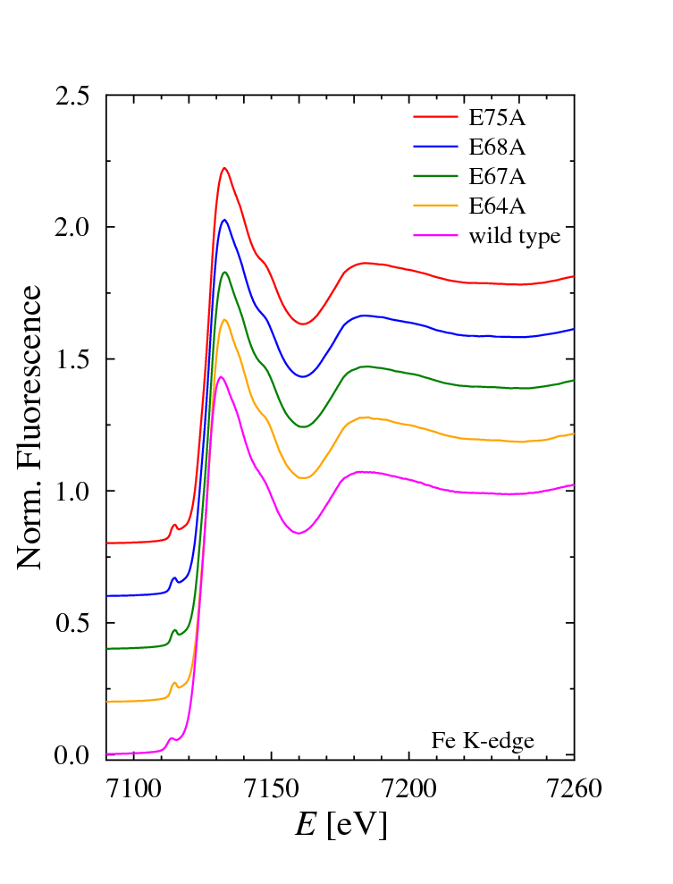

Figure 1.

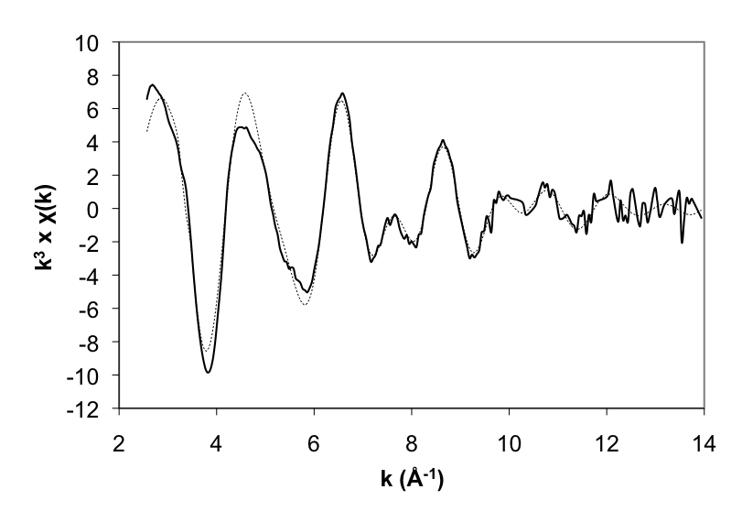

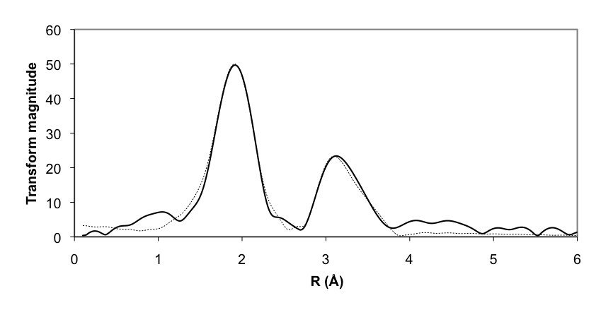

Figure 2.

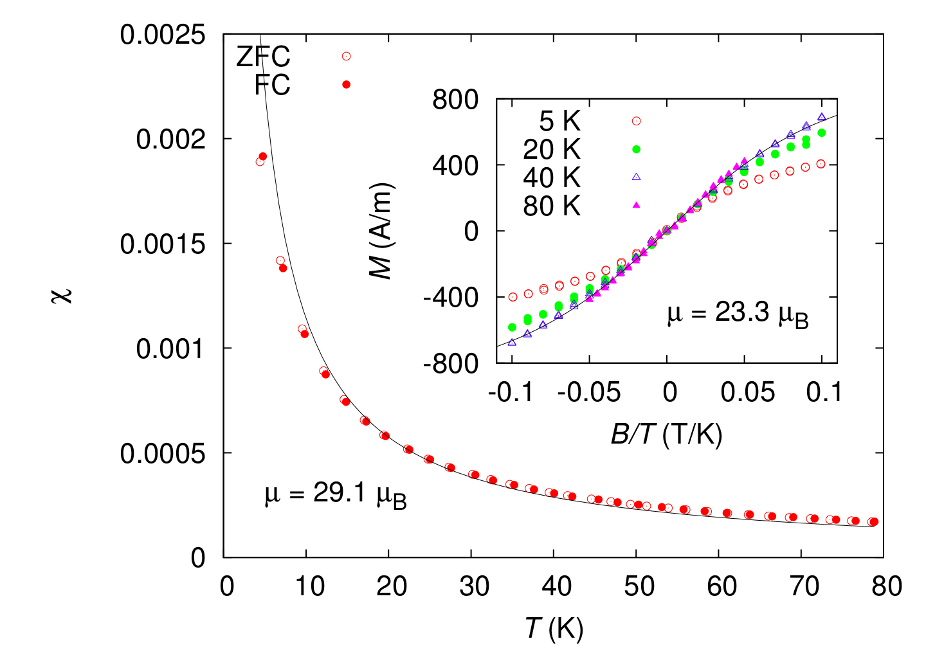

Figure 3.

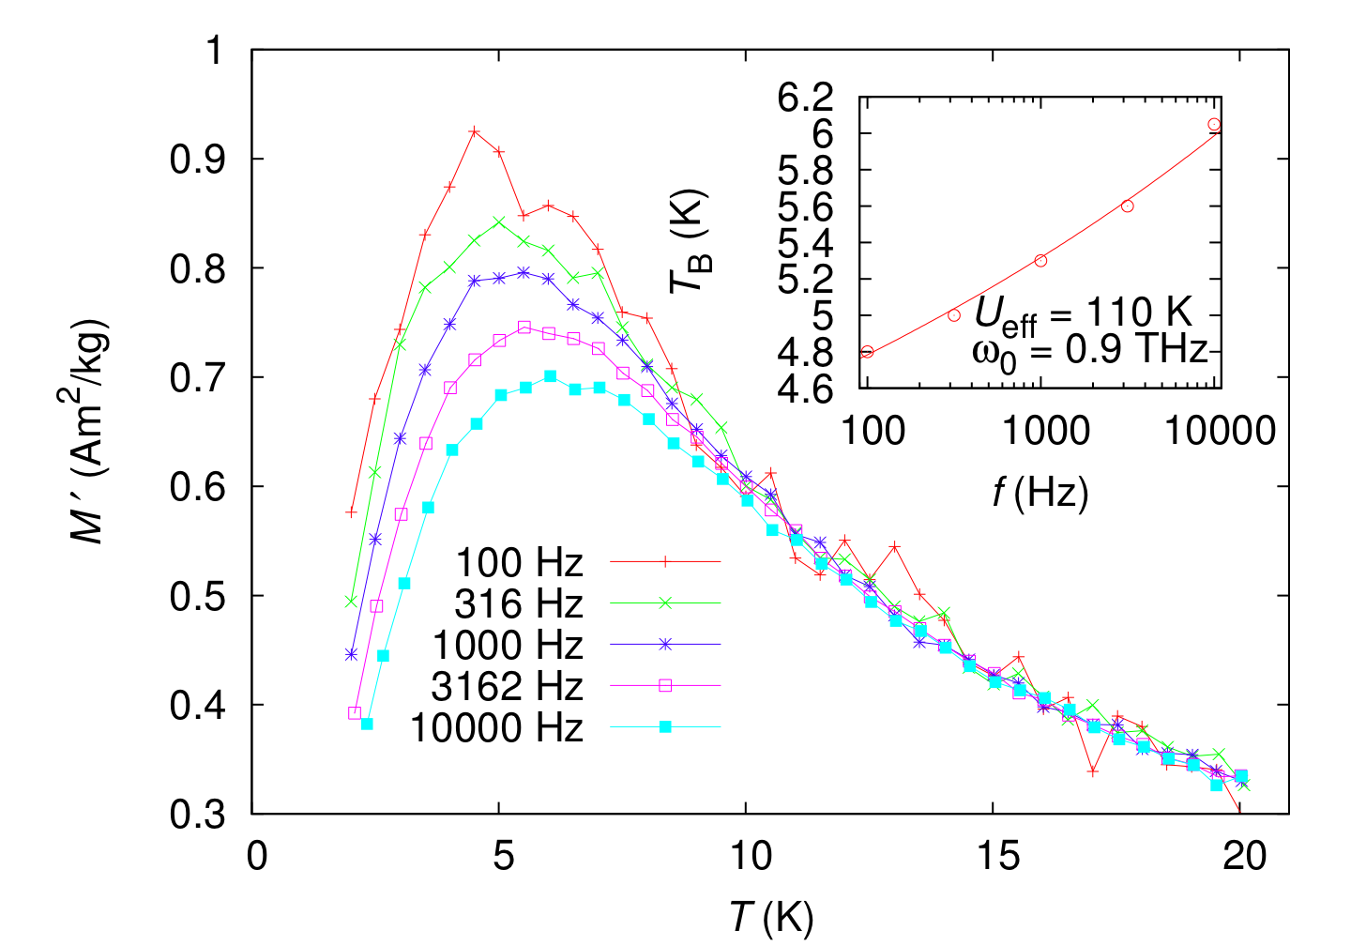

Figure 4.

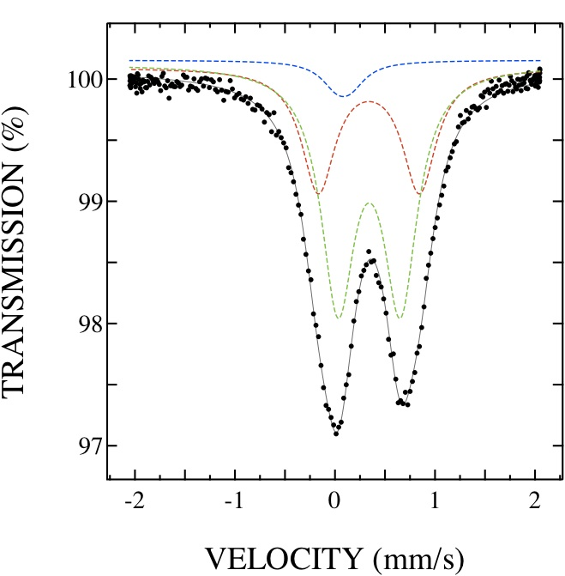

Figure 5.

Supplementary information

Table 1. Iron content in wild-type SsDpr and in the point mutants.
Protein | N_{Fe} / dodecamer
Wild-type SsDpr | 293 ± 4
E64A | 238 ± 4
E67A | 235 ± 6
E68A | 251 ± 4
E75A | 255 ± 3

Table 2. Primers used for mutagenesis.#
Primer | Sequence
E64ASm | CCA AAG ATG GAT GCG TAT ATG GAA GAA ATT G
E64AR | CCA AAT CAT AAA GCC ACG ACC ACG CAT ATA CCA G
E67ASm | G GAT GAA TAT ATG GCG GAA ATT GAT GGT TAT TTG
E67AR | AT CTT TGG ATG CCA AAT CAT AAA GCC ACG ACC AC
E68ASm | GAA TAT ATG GAA GCG ATT GAT GGT TAT TTG GAT G
E68AR | ATC CAT CTT TGG ATG CCA AAT CAT AAA GCC ACG AC
E75ASm | GAT GGT TAT TTG GAT GCG ATG AGT GAG CGT TTA ATC
E75AR | AAT TTC TTC CAT ATA TTC ATC CAT CTT TGG ATG C
#The sites of mutation are shown in bold.

Table 3. Data processing statistics.#
 | E64A | E67A | E68A | E75A
Data processing
Beamline | EMBL-DESY X12 | EMBL-DESY X12 | EMBL-DESY X12 | EMBL-DESY X12
Wavelength | 1.72003 | 1.72003 | 1.72005 | 1.72196
Space group | P2₁2₁2₁ | P2₁2₁2₁ | P2₁2₁2₁ | P2₁2₁2₁
Unit cell dimensions  a, b, c (Å) | 104.9, 137.3, 141.4 | 105.5, 137.7, 142.2 | 104.5, 137.5, 141.6 | 104.5, 137.8, 142.0
No. of molecules | 12 | 12 | 12 | 12
Resolution range (Å) | 50.0-2.70 (2.85-2.70)# | 20.0-2.85 (2.92-2.85) | 25.0-2.20 (2.32-2.20) | 40.0-2.40 (2.53-2.40)
No. of reflections | 800192 (114428) | 504322 (36232) | 1314802 (175925) | 928435 (63958)
No. of unique reflections | 56776 (8158) | 48830 (3570) | 103932 (15054) | 74271 (7148)
Completeness (%) | 100.0 (100.0) | 99.5 (99.6) | 99.9 (100.0) | 92.3 (61.9)
<I/σ(I)> | 20.2 (5.2) | 22.3 (3.6) | 17.7 (6.5) | 25.4 (5.8)
R_{merge} (%) | 9.2 (53.0) | 10.6 (73.0) | 10.2 (36.4) | 6.6 (34.6)
Wilson B-factor (Å²) | 65.5 | 46.8 | 31.1 | 48.8

#Numbers in parentheses correspond to the highest resolution shell.

