# Industrialization of European XFEL preparation cycle “BCP flash” at Ettore Zanon Company

A. Matheisen, B.v.d. Horst, N. Krupka, M. Schalwat, N. Steinhau-Kühl, A. Schmidt, W. Singer, DESY Hamburg, Notkestrasse 86, D22607 Hamburg, Germany  
P. Michelato, L. Monaco, INFN Milano – LASA, Via Fratelli Cervi 201, 20090 Segrate, Milano, Italy  
G. Corniani, Ettore Zanon S.p.A., Via Vicenza 113, 36015 Schio VI, Italy

Abstract

In the Specification for XFEL Cavity preparation two different preparation sequences are presented. Ettore Zanon Company as one of the two companies contracted for XFEL cavity production and preparation has chosen the so called BCP flash cycle. To fulfil the requested work flow, quality of infrastructure and processes, the company set up a complete new infrastructure in refurbished fabrication halls. The layout of the facility, set up of work flow of preparation and test results of resonators processed by Ettore Zanon in their infrastructure will be reported.

## Introduction

A total of 800 XFEL cavities and 24 High Grad resonators [1] are ordered at Industry. An order of 400 XFEL +12 high grade cavities is placed at Ettore Zanon (EZ) in Italy. The EZ Company decided to make use of the BCP flash preparation sequences to reach the cavity performance requested by DESY.

For this project the company had to extend the existing infrastructure in a refurbished manufacturing hall [2] of 1200 m2 (Figure 1) ground space and air quality of ISO 10 a completely new infrastructure for cavity preparation is set up, A cleanroom with160 m2 of ISO 4 quality and 220 m2 of ISO 7 air quality is installed inside this hall. Ultrasonic cleaning (USC) and ultra- pure water rinsing line (UPW), closed loop Buffered Chemical Polishing (BCP) (Figure 2), one for the BCP flash chemistry and one for outside etching. Ultra-pure water rinsing and ethanol rinsing facility are integrated in the ISO 7 area as well. In ISO 4 area slow pumping- slow venting units (SPSV) [3] and two high pressure water rinsing stands (HPR) are integrated. FMS integration, cavity drying after HPR, assembly of accessories and vacuum checks are performed in the ISO 4 area as well.

A new UHV 800 C annealing oven (Figure 3), four 120 C baking ovens, a semi-automatic chemical plant for parts etching before EB welding and a local BCP bench for accessory etching are set up inside this hall as well.

In addition several new machines, test benches and a safety room for pressure test are integrated into the hall.

During the start-up of the cavity preparation a new electropolishing facility is designed and set up by EZ to minimize transports and optimize material flow [4].

## Qualification of infrastructure

Four DCV cavities are in use to set up infrastructure, determine process parameters, for training of personnel and establishing of the process flow [1, 5].

Release for processing XFEL cavities in the infrastructure is given after intensive studies and training by DCV. After passing tests at 2 K with RCV cavities successful up to step RCV 6 (table 2) release for pre-series cavity preparation is given. Series production is released after eight pre-series cavities (PCV) are successfully tested.

Figure 1: View on the ISO 7 area of EZ cleanroom. Left: BCP stand inside- and outside etching; Right automated cleaning facility.

### Pre- qualification of Main Infrastructure

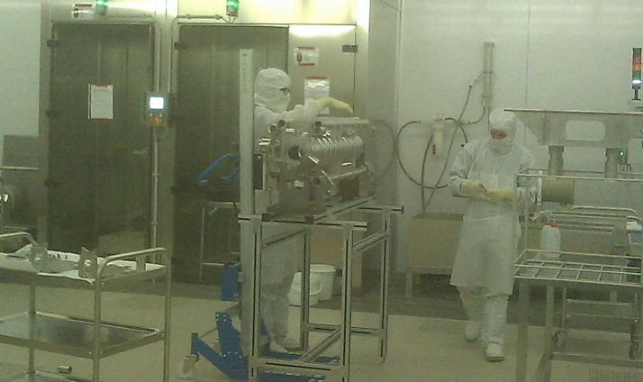

Figure 2: chemistry area inside ISO 7 cleanroom at EZ S.p.A. Left: closed loop BCP for BCP flash and outside etching.

Parts of the infrastructure are prequalified by standard test (Table 1).

Only after passing these tests, permission for RCV treatment is given.

Table 1: Condition for pre-qualification of infrastructure

|  |  |
| --- | --- |
| Cleanroom + Assembly area (ISO 4) | Air particle counter, airspeed control, fog generator under status in Operation. |
| Ultra- pure water system | TOC -; resistance sensors; liquid particle counter integrated in the UP water line |
| HPR (ISO4) | TOC and liquid particle counter, Pressure stability; Program parameter check |
| BCP facilities  (ISO 7) | Filling -and dump time; Temperature- and flow stability. |
| US cleaning (ISO7) | Samples and DCV cavities drip off test; RGA at SPSV and 800 C oven |
| SPSV units (ISO 4) | RGA, total end pressure, air particle control |
| EP facility | Flow rate, temperature stability; filling-and dump time. Current- and voltage stability |
| 800 C UHV Oven | UHV pressure RGA and Nb Samples test |
| Personnel (ISO4) | Training units, air particle counter; leak check of test objects. |

### Qualification by RCV Test Sequences

Four resonators (CAV0500; CAV0502; CAV0503; CAV0506) are handed to DESY for processing according to BCP flash sequence. CAV0500, CAV00503 and CV00506 reached gradients of 34 to 36MV/m without field emission, while CV00502 showed electron loading and a max gradient of 30MV/m.

These cavities are hand out to the EZ SPA and served for the qualification processes RCV 0 to 9 (Table 2).

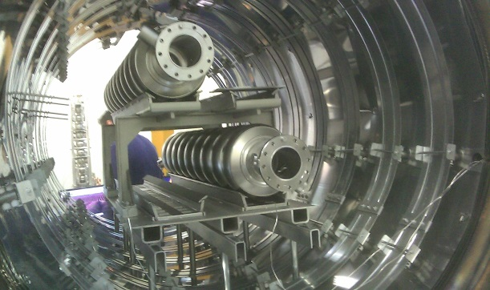

Figure 3: 800 C UHV oven loaded with two XFEL serial cavities.

With exception of Step RCV 2 and RCV 4 the cavities reproduce the gradient as shown at first test at DESY.

Sequence RCV 2 for qualification of the first HPR (step 2) needed to be redone (step 2.1) due to contamination of the SPSV system while step RCV 4, qualification of BCP treatment, handling problems during first time process flow (step 4) are most probably caused the high field emission loading. A repetition of this sequence (step 4.1) was done successfully.

Table 2: Surface treatment steps tested successfully with RCV test sequences

|  |  |  |  |  |  |  |  |  |
| --- | --- | --- | --- | --- | --- | --- | --- | --- |
| Sequence  Step | 0 | 1 | 2.1 | 3 | 4.1 | 5 | 6 | 7.3 |
| Transport | X | X | X | X | X | X | X |  |
| Slow venting |  | X | X | X | X | X | X |  |
| Remove pumping port |  |  | X | X | X | X | X |  |
| Dismount accessories |  |  |  | X | X |  |  |  |
| Main EP |  |  |  |  |  |  |  | X |
| BCP flash treatment |  |  |  |  | X |  |  | X |
| Install all accessories |  |  |  | X | X |  |  | X |
| HPR 1 |  |  | X | X | X |  |  | X |
| HPR 2 |  |  |  |  |  |  | X |  |
| Mount pumping port |  |  | X | X | X | X | X | X |
| Slow pumping |  | X | X | X | X | X | X | X |
| 120 C baking |  |  |  |  |  | X |  | X |

The final qualification of the main EP at EZ two serial cavities (CAV599 and CAV600) passed the complete treatment cycle of BCP flash with main EP done at EZ. Both of them reached above 30 MV/m without field emission.

### Ramp up of Production by PCV Resonators

After release of the infrastructure the first 8 cavities named pre-series cavities (PCV) passed the complete cavity processing for the first time.

The complete workflow of production, surface processing, quality control and handling by new personnel working in shifts with the new infrastructure had to be shown with this PCV cavities (Fig. 4).

The cavities build according European Pressure Equipment Directive PED 97/23/EC [6] are equipped with He-tank, HOM- High-Q and Pick up antennas. They are handed to DESY in “ready for string assembly” conditions. Relaxed conditions on time schedule and acceptance criteria as they are foreseen for series were accepted by DESY for the PCV resonators.

The cavities CAV00511 andCAV00515 were limited at low field by field emission caused by ramp up problems. After additional HPR they performed at 26.2 resp. 27.7 MV /m without field emission loading.

Figure 4: Test results of the eight pre series cavities made by Ettore Zanon.

Two other PCV cavities, CAV00513 and CAV00516, are limited by quench at 19 resp. 22 MV/m without field emission loading. Origin of this limitation is under investigation.

## Series Cavity production

Since start of the production of XFEL cavities in December 2012 until KW 36 /2013 a total of 106 cavities ae handed out to DESY. Seventy nine of them are tested at 2 K. Sixty seven of the handed out XFEL cavities are fabricated by DESY by Ettore Zanon.

Delivery rates up to four SCV per week will be reached by EZ in September 2013. Due to overloaded EP facility at the subcontractor RI and a delay in qualification of the new EP facility at E.Z. S.p.A. this sequence was reduced to 2.5-3 SCV per week. Since August 2013 the EZ designed main EP facility is qualified [4] and full production rate is re-established (Fig. 5).

The fifty six EZ resonators tested until KW 36/13 reached an average acceleration gradient of 27.6 MV/m. The average of the usable gradient, defined by quality factor of Q >1x1010 and field- emission level of < 1x10-2-mGy/min, of these cavities is 24.5 MV/m in the first pass. Thirty of the EZ cavities well exceeded gradients of 30 MV/m, one cavity reached up to 37MV /m without field emission loading.

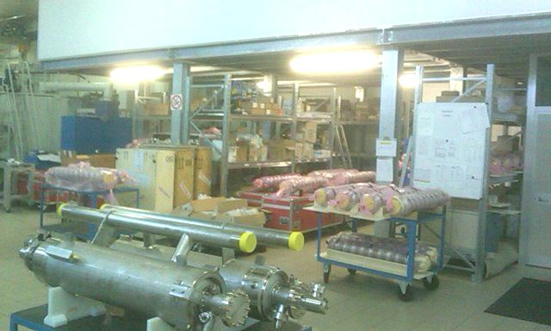Figure5: View on production buffer at Ettore Zanon.

The cavities not passing the acceptance test in first test are retreated by HPR at DESY. Eight are retested so far and recovered form field emission. They reached gradients from 26 up to 34 MV/m with average usable gradients of 39.2 MV/m.

After second pass maximum average gradient went up to 30.4 MV/m and the usable gradient reached 28.4 MV/m.

A total of five SCV cavities showed quench limitation without field emission between 19 MV/m and 22 MV/m. Retreatment of this cavities and investigation on this limitation are on-going.

## Summary

At Ettore Zanon Company located at Schio Italy, a complete new industrial infrastructure for s.c. cavity preparation is set up. Qualification of the infrastructure and fabrication processing flow is done with nine referencing preparation cycles and eight pre-series cavities.

Cavity production is ramped up in January 2013. Until KW 36/13 a total of sixty seven cavities are handed over to DESY. The fifty three resonators tested so far reached average gradients of more than 28 MV/m. About half of that production exceeded gradients of 30 MV/m. A production rate of 4 cavities per week reaching acceptable performance is demonstrated.

## References

[1] W. Singer, J. Iversen, A. Matheisen, H. Weise (DESY, Hamburg, Germany), P. Michelato (INFN, Milano, Italy), The Challenge and Realization of the Cavity Production and Treatment in Industry for the European XFEL, these proceedings.

[2] Giorgia Massaro, Giorgio Corniani, Ettore Zanon S.p.A., Schio, MOP038,  Series Production of XFEL 1,3 GHz SRF Cavities at Ettore Zanon S.p.A., Management, Infrastructures and Quality Control.

[3] L. Lilje, Particle Free Pump Down and Venting of UHV Vacuum Systems, SRF2009.

[4] Michela Rizzi, Ambra Gresele, Ettore Zanon S.p.A., Schio, Axel Matheisen, Nicolai Steinhau-Kuehl, DESY, Hamburg), Paolo Michelato,INFN/LASA, Segrate (MI), MOP045, Electropolishing for XFEL Cavities Production at Ettore Zanon SpA.,Corniani, M.Rizzi, E.Zanon, MOP 45c.

[5] A. Matheisen, B.v.d. Horst, N. Krupka, M. Schalwat, N. Steinhau-Kühl, A. Schmidt, W. Singer, P. Michelato, L. Monaco, Strategy of technology transfer of XFEL preparation technology to industry, these proceedings.

[6] A. Matheisen, A. Schmidt, W. Singer, J. Iversen, Implementation of European Pressure Equipment Directive (PED) for certification of 1.3 GHz superconducting resonators for the XFEL project, to be published.