Electropolishing for EXFEL cavities production

at Ettore Zanon SpA
M. Rizzi#, A. Gresele, Ettore Zanon SpA, Schio, Italy
A. Matheisen, N. Steinhau-Kühl, DESY, Hamburg, Germany
P. Michelato, INFN, Milano, Italy

Abstract
A new horizontal electropolishing facility has been developed by Ettore Zanon SpA (EZ) and implemented for the series production of the EXFEL cavities at EZ. Main electropolishing done according to EXFEL specification is the first step in the surface treatment process, that is essential to reach high performances.
Particular attention has been dedicated to find the best configuration during qualification of the system. Correlation between process variables for industrial application, RF tests at room temperature at Zanon and vertical RF tests at 2 K at DESY are investigated, in order to optimize the removal of Niobium.
The facility has been designed for industrial scope, in order to guarantee the required quality and a production rate of 4 cavities per week . One of the most important aspects for design has been the automation of the process that permits to have complete control on it.

INTRODUCTION
Ettore Zanon SpA has started a 1.3GHz cavity production for the European XFEL. Beginning on 2012, 420 cavities have to be produced for the EXFEL facility at DESY - Hamburg.

BCP flash scheme
Cavities with outstanding and stable performances are required, in order to be acceptable for the accelerator. Minimum goal is 23.5 MV/m with Q₀= 1x10¹⁰ and low field emission. Until week 37/2013 cavities with acceleration gradients up to 36.9 MV/m with Q₀ = 1.9x10¹⁰ have been produced by EZ.
Such high gradients can be reached on a stable basis only applying specific surface treatment, like electropolishing [1]. The inner surface of the cavities must be as smooth as possible, without defects or contaminants.
Two different chemical treatment are considered to prepare a cavity surface: Electropolishing (EP) and Buffered Chemical Polishing (BCP) [2] .
For the production of the cavities for the XFEL two possible ways are considered: BCP flash scheme and final EP scheme. Ettore Zanon SpA follows the BCP flash production scheme, that consider 140 µm EP as first cleaning, followed by 10 µm BCP after helium tank integration.
After welding, cavity is degreased in a ultrasonic bath and rinsed with ultrapure water in a clean room of ISO7 standard.

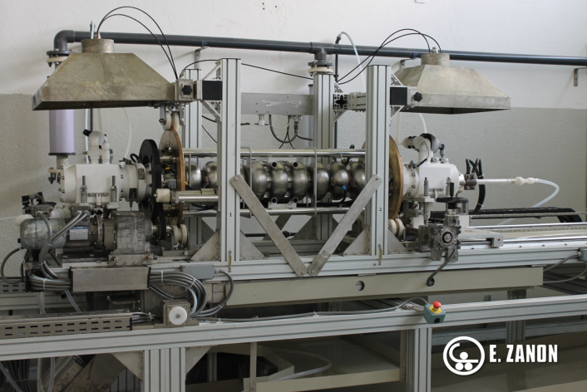
Figure 1: EP bench
_______________________________
# mrizzi@zanon.com
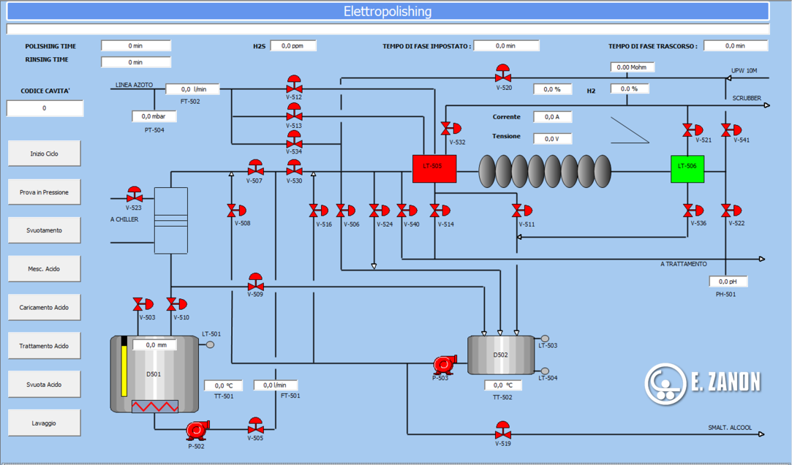
Figure 2: Process flow diagram
First surface treatment is to remove 140 micron Niobium with EP treatment in a facility outside the cleanroom. After chemical process, cavity is rinsed with ultrapure water (UPW) to remove acid residues. Rinsing is completed with a short high pressure rinsing (HPR) inside ISO4 cleanroom [3].
Sulphur is produced during EP by a side reaction and must be removed dissolving it with ethanol [4]. Another problem related to EP is H₂ adsorption in the Niobium material. The cavity is therefore recovered with a 800°C annealing treatment.

EP facility
EP plant (Figure 1) has been developed by the technical department of Ettore Zanon SpA, following specifications and hints given by experts from DESY. The facility is designed as a horizontal EP of 1.3GHz - 9 cell cavities. The cavity is kept under rotation at 1rpm during treatment The polishing bench can be placed in vertical position for water leak test and rinsing. Automatic movements are handled by a PLC by means of position sensors.
The rotation is transmitted to the frame of the cavity by a pulley, connected to a motor shaft. Two brass slewing rings support the frame and the cavity, permit the rotation movement and are used for current transmission.
An aluminium pipe of 99.5% purity is in use as a cathode and inserted inside the cavity 14 mm above the irises. Nine holes placed in correspondence with equators are used for acid distribution. A tubing is placed right above the cathode, with holes on the whole length to guarantee a homogeneous distribution of the nitrogen overlay. The cathode is shielded with Teflon tape, to reduce reaction rate.
PFA and PVDF are in use for rigid and flexible piping for the acid line. All other parts that may be in contact with acid are made of fluorinated polymers (PTFE).
The plant has two PVDF tanks: the first one serves as main storage tank, the other serves as buffer to pump back acid from the cavity to the main storage tank. A heat exchanger is installed in the return line to the main storage tank to cool down the acid. Acid level in the cavity is maintained by an overflow system and is kept under control by two level switches (Figure 2).
Plant is serviced with ultrapure water (18MOhm*cm resistivity) and pure nitrogen 99.999%.
Exhaust gases are sucked and conveyed to a scrubber, moreover H₂ and HF sensors are installed in the room and in the piping system to ensure personnel and explosion safety.

Treatment details
EP is done using a mixture of sulphuric acid and hydrofluoric acid 9:1. Acid can be used up to 10 g/l of dissolved Niobium without significant removal rate reduction. In order to control removal rate, current and temperature values must be kept under control. The best solution found for reaction control and fast response has been to use an ON/OFF controller to relate heat exchanging to current value, instead of temperature value. Temperature tends to increase during the 6 hours treatment, but remains at acceptable values (Figure 3).
During EP, a nitrogen overlay continuously flow through the cavity, to remove hydrogen and avoid explosive atmosphere build up.
Electropolishing treatment is composed by a series of operations [3]:
- After installation of cavity in EP bench, a pressure test with ultrapure water is performed, to control that there is no leak on piping connections,
- Cavity and piping are drained using nitrogen, to avoid acid – water contact,
- Horizontal cavity is filled with acid up to the set level and voltage is applied,
- Reaction proceeds for approximately 6 hours, at constant voltage (17 V),
- Cavity is drained using nitrogen and then is rinsed before removing it from bench.
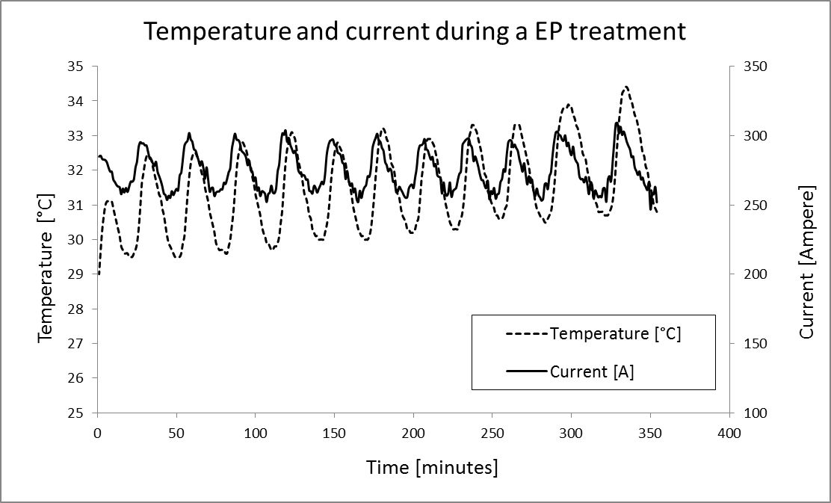
Figure 3: Temperature and current trend during a EP treatment

First results
Reaction rate and actual removal are always controlled by weighting cavity before and after treatment and by measuring thickness of a sample installed at the main coupler port. Measuring of surface thickness by means of a ultrasonic thickness gauge is under investigation. A Krautkramer Branson CL3 Ultrasonic Thickness Gauge with sensor Alpha 20/125 016dry is in use. The aim is to collect some data on removal difference from equator to iris. Average removal rate of approximately 0.4 µm/min is experimentally found, that is consistent with the theoretical value [5]:
$$r\left[\frac{μm}{min}\right]= \frac{I∙M_{Nb}∙60∙{10}^{5}}{q_{e^{-}}∙5∙N_{A}∙ρ_{Nb}∙S_{cav}}= 1.484∙{10}^{-3} I\left[A\right] ,$$
where:
r = removal rate, as µm/min,
I = current intensity [A],
M_{Nb} = Niobium molecular mass, 92.9 g/mol,
$q_{e^{-}}$ = electron charge, 1.6*10⁻¹⁹ C,
N_{A} = Avogadro constant,
ρ_{Nb} = Niobium density, 8570 g/dm³,
S_{cav} = inner surface of a 1.3GHz cavity, 91 dm³,
5 = oxidation state of Niobium.

However, removal is not homogeneous along the cavity surface. Figure 4 and 5 show data taken from measurements of the first four series cavities that performed main EP. There is higher removal at the irises than at the equators.
Removal at equators is less important for the maximum acceleration gradient, but a too low removal of the damage layer at equators may cause a quench at low gradients, because this is the region of highest magnetic field. Therefore, if the removal at equators is not sufficient, the cavity will have bad performances.

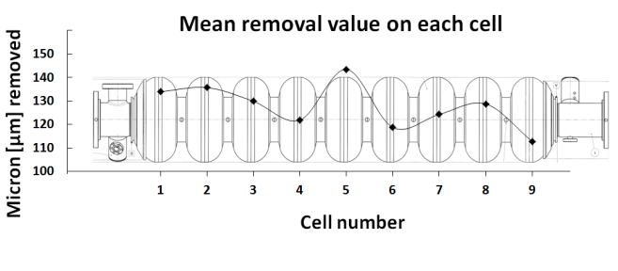
Figure 4: Mean removal on the different cells of a cavity.

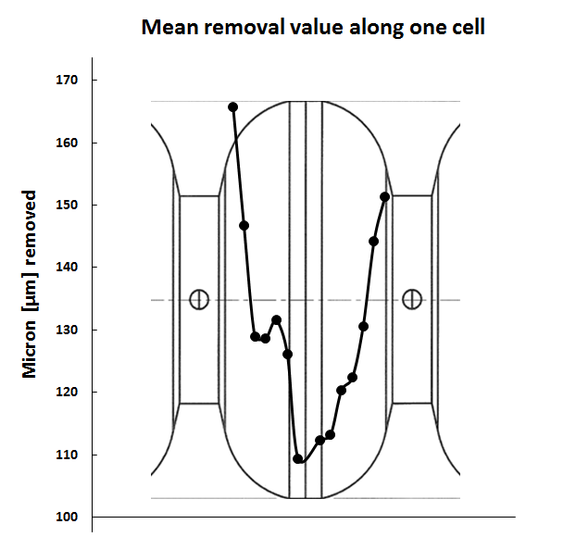
Figure 5: Micron removed on the different parts of a cell.

A critical variable for this ratio has been the shielding of the cathode with Teflon tape. The best configuration found has a 40 mm opening at each equator. Tests with smaller openings (down to 15 mm) have been performed
to optimize iris/equator removal ratio, but the results are not satisfactory, because the grain boundaries become evident and the surface is not smooth anymore.
As reported in Table 1, the new EP facility has been qualified by the first two series cavities that have undergone the full treatment at EZ. They reached above 30 MV/m without field emission.

Table 1: Performance of first two series cavities treated.
CAV n° | E_{acc} max | Q₀ max
599 | 30.9 MV/m | 2.6 x 10¹⁰
600 | 30.7 MV/m | 2.6 x 10¹⁰

conclusion
Ettore Zanon SpA is contracted for 400 XFEL and 12 High Grade cavities. For an optimized and stable flow of the production, an EP facility for main EP treatment is designed and set up by EZ. Studies are made to optimize removal of Niobium during the main EP process. After commissioning in July 2013 the new facility is qualified by 2 XFEL resonators that reached gradient of 30 MV/m without field emission. The new EP facility at EZ is now under full operation and serves for the XFEL production at EZ at a rate of 4 cavities/week.

Acknowledgment
We would like to thank the operators that were so helpful in building this new EP facility and the technical staff that worked for development and start up.

References

[1] | G. Ciovati et al., "Final Surface Preparation for Superconducting Cavities," TESLA Technology Collaboration, 2008.
[2] | Hasan Padamsee, RF Superconductivity. Weinheim: Wiley VCH, 2009.
[3] | Deutsches Elektronen Synchroton DESY, Series surface and acceptance test preparation of superconducting cavities for the European Xfel, 2009, XFel/A - D, Revision B.
[4] | A. Matheisen et al., "Electro-polishing surface preparation for high gradient cavities at Desy," in Proceedings of the Particle Accelerator Conference, Knoxville, Tennessee, 2005, pp. 3304 - 3306.
[5] | E. Schultz et al., "Engineering solutions for the electro-polishing of multi-cell superconducting accelerator structures," in The 10th Workshop on RF Superconductivity, Tsukuba, Japan, 2001, pp. 481-484.

