Industrialization of European XFEL preparation cycle “final EP ” at Research instruments Company
A. Matheisen , B.v.d. Horst, N. Krupka, M. Schalwat, M. Schmökel, A. Schmidt,W. Singer, DESY Hamburg, Notkestrasse 86, D22607 Hamburg, Germany, P. Michelato, L. Monaco, INFN Milano,Via Fratelli Cervi 201, 20090 Segrate, Milano, Italy, M. Pekeler, Research Instruments GmbH, 51429 Bergisch Gladbach, Friedrich Ebert Straße 1, Germany

Abstract

In the “Specification for XFEL cavity Preparation two different preparation sequences are presented and left for the choice of processing sequence to the companies. Research Instrument Company (RI) as one of the two companies contracted for XFEL cavity production and preparation has chosen the so called “final EP” cycle. Major infrastructure components like EP facility and the BCP facility were pre-qualified for RI. This existing and the new set up areas like the cleanroom are distributed over the ground area of the Technology Park Bergisch Gladbach. The process flow given in the DESY specification needed adaptation to this scenario. Additional infrastructure beside the once specified needed to be set up to ensure the same quality of processes even with a changed workflow. The general layout of the facility, matched work flow of preparation and test results of resonators processed by RI in their infrastructure will be reported.

Introduction
A total of 800 XFEL cavities and 24 High Grade (HG) resonators [1] are ordered at Industry. For the 400 + 12 cavities ordered at Research Instruments GmbH (RI) at Bergisch Gladbach Germany. The RI decided to make use of the “final EP” preparation sequences to reach the requested cavity performance.

The company could make use of existing and qualified infrastructure like the electropolishing facility (EP), the Buffered Chemical Polishing (BCP) in open basins and electron beam welding machines (EBW) for this project. Some additional new infrastructure needed to be set up to fulfil the requirements of cavity preparation according to the XFEL specification.
It was decided to provide all 400 helium tanks, made from Titanium and according to Pressure Equipment Directive (PED) for pressure bearing parts of the XFEL linac, to RI by DESY. The tanks are fabricated at E.Zanon, SPA and CSC Company in Schio, Italy [2] and DESY took over the PED regulations for module B1 and B [3]. TÜV Nord GmbH at Hamburg was nominated as notified body for this project.

Adapation of process flow and infrastructure for the EXFEL project
The existing infrastructure at RI is distributed over the ground area of the Technology Park Bergisch Gladbach where the re-organization or set up of new buildings is excluded.
A sophisticated logistic is set up that guaranties the cleanliness and handling conditions, as requested by the XFEL specification and the capability to ensure the delivery rate of up to 5 cavities / week . The boundary condition of the ground area requested to install the new ISO 4 cleanroom of 120 m2 at a first level platform inside building 19c as shown in Figure 1.

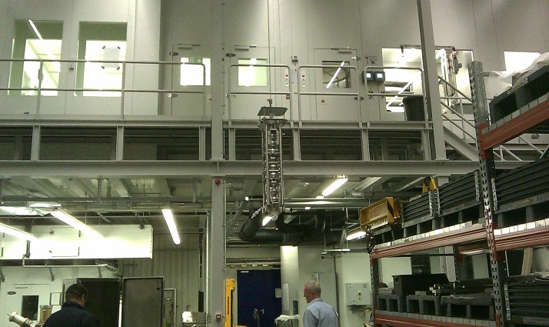
Figure 1: View of Cavity Transport to ISO 4 Cleanroom at First Floor Level.

Two high pressure rinsing stands, slow pumping/ slow venting vacuum units (SPSV) [4], drying and assembly areas are integrated in this cleanroom. No degreasing with detergent can be applied in the area of hall 19c, due to internal regulations. The automated car wash, ultra-sonic and ultra-pure water rinsing basin also located in ISO 4 area are supplied by ultra-pure water only.
A new UHV oven for 800 C annealing of Nb cavities is added to hall 19d at ground level, while the new 120 C baking ovens are located on a platform at 1st floor level of this building.

Adaptation of Processing Flow
To ensure highest cleanliness of cavities before UHV heat treatment, the XFEL specification puts the step outside etching of cavities just right before introduction of the resonators to the 800 C oven. To optimize the logistics and adapt preparation sequences to the existing infrastructure at RI, outside etching has to take place before main EP. Outside etching at RI is done by immersing the resonator into the BCP basin while the end groups are sealed protecting by covers. The re-arrangement of preparation sequences had to assure the required cleanliness for the 800 C annealing process like requested by the XFEL specification.

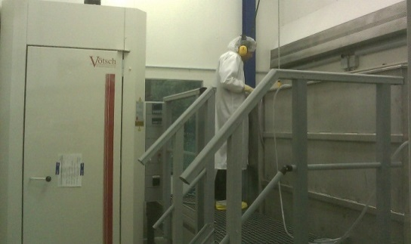
Figure 2: View on the new ISO7 Clean Room, Left: ISO 4 Drying Oven; Right: Cleaning and Rinsing Basins.

To guaranty surface cleanliness at 800 C UHV annealing and to compensate the missing cleaning with detergent at the entry to ISO 4 cleanroom, a new ISO 7 cleanroom of about 15 m2 ground space is set up next to the main EP facility in building 29. Ultra-sonic cleaning with detergent, ultra-pure water rinsing equipment and low temperature drying oven of ISO 4 air quality are integrated in this new cleanroom. In addition the air quality of the EP area is upgraded to ISO 7 class (Figure 2).
A transport box is designed for handover of cavities between the different buildings. This box allows transport over roads and ensures that no contamination by hydro carbon or other air born contaminations can settle on the surfaces during transport.
The adapted work flow and the new hard ware are pre-qualified by samples and treatments of dummy cavities (DCV) successfully. Samples and DCV were polluted with oil and grease as in use in the company. Drip off test and Residual Gas Analysis (RGA) testing of samples at the SPSV units and the 800C oven did not show any hint for hydrocarbon contamination after passing the new ISO7 cleanroom cleaning process.

Qualification of infrastructure
Four reference cavities (RCV) cavities are in use to set up infrastructure, training of personnel and establish process flow [5].
Release for processing of pre-series cavities in the infrastructure is given only after successful test at 2 K of those RCV cavities up to step RCV 5 (table 2). Series production is released after eight pre-series cavities (PCV) were successfully tested.

Pre-qualification of Main Infrastructure
Parts of the infrastructure are prequalified by standard test (table 1). Only after successfully passing these tests, permission for RCV treatment is given.

Table 1: Conditions for Pre-qualification of Infrastructure
Cleanroom (ISO 4) | air particle counter, airspeed control, fog generator
Ultra- pure water system | TOC recording; resistance sensors; liquid particle counter integrated in UP water line.
HPR (ISO4): | TOC and liquid particle counter, Pressure stability; Program parameter check
US cleaning (ISO 7) | drip off test
SPSV units (ISO 4) | RGA, total end pressure, air particle control
EP facility | flow rate, temperature stability; filling- and dump time. Current and voltage stability.
ISO 7 cleanroom | drip off test on samples and resonators, Particle control(air particle counter); RGA at SPS and 800 C oven
800 C UHV Oven | UHV pressure RGA and Nb Samples test
Personnel | Training units, air particle counter; leak check of test objects in ISO4.

Qualification by RCV Test Sequences
Four RI made resonators (CAV0001,CAV0002, CAV0003 and CAV0004) passed the preparation sequence “final EP” at the qualified infrastructure of DESY and reached acceleration gradients from 27 to 34 MV/m (table 3). After this referencing treatment these cavities are hand to the RI company and served for the qualification processes RCV 0 to 6 (Table 2).
For step RCV 1 a readjustment of the SPSV units was need before final qualification. At RCV 3 a leakage to the helium bath is detected during test and test had to be stopped. A second cavity passed RCV 3 sequence successfully and reproduced the value as tested by DESY before.
Step RCV 4 was passed after some fine adjustment of HPR 2 set up and additional training of the cleanroom team working in the second work shift.
After first failures on Step RCV 4, origin form handling and processing problems, two new cavities from start-up of cavity preparation (CAV0009 and CAV00012) are tested. They passed the complete treatment cycle of final EP with main and final EP done at RI . They showed acceleration gradients of 28 resp. 30.5 MV/m without field emission. They were accepted by as qualification for RCV 4 sequence and PCV as well.

Table 2: Surface Treatment Steps Tested with RCV Test Sequences.
RCV  Treatment | 0 | 1.1 | 2 | 3.1 | 4.3 | 5 | 6
Transport | X | X | X | X | X | X | X
Slow venting |  | X | X | X | X | X | X
Dismount pumping port |  |  | X | X | X | X | X
Dismount all accessories |  |  |  | X
HPR 1 |  |  | X |  | X | X
HPR 2 |  |  |  |  |  |  | X
Final EP treatment |  |  |  |  | X
Mount all accessories |  |  |  | X
HPR 1 |  |  |  | X
HPR 2 |  |  |  |  | X | X
Mount pumping port |  |  | X | X | X |  | X
Slow pumping |  | X | X | X | X |  | X
120 C baking |  |  |  |  |  | X

Ramp up of production by PCV resonators
After release of the infrastructure the first 8 cavities out of the production, named pre-series cavities (PCV), passed the complete cavity processing and companies logistic for the first time. Beside this ramp up of cavity preparation these resonators served for test module B of PED [3] as well. They were accompanied by TÜV North from start of mechanical production in the machine shop until the pressure test of cavity integrated into Helium vessel. PCV cavities are handed over to DESY as “ready for module installation”.

Figure3: Test Results of eight Pre-series Cavities Left scale: Quality Factor Qo. Right scale: Radiation Level (mGy/min).
Relaxed conditions on time schedule and acceptance criteria as they are foreseen for series production were accepted by DESY for the PCV resonators.
With PCV resonators all new hardware, workflow of processes, quality control, personnel working in shifts and the tank welding procedure is ramped up for production rates of 4 cavities per week.

The cavities 0009; 00011; 00012; 00013 and 0023 reached gradients between 27 and 31MV/m without showing significant field emission loading (Figure 3). CAV00014 and CAV00017 are limited at 20 resp. 24.6 MV/m with high electron loading. They recovered to 29 resp. 36 MV/m by additional HPR done at DESY.
CAV00010 is limited at 24.2 MV/ m without showing field emission loading.

Series Cavity production
Since start of production of XFEL cavities in December 2012 until KW 36 /2013 a total of 106 cavities are handed out to DESY. Seventy nine of them are tested at 2 K. Thirty nine of the handed out XFEL cavities are fabricated by Research Instruments Company.
Stable delivery rates up to four SCV per week will be reached by Research Instruments in October 2013. Twenty two RI resonators tested until KW 36/13 reached average acceleration gradients of 28.8 MV/m. The average of the usable gradient, defined by quality factor of Q >1x10¹⁰ and field- emission level of < 1x10⁻² mGy/min, of these cavities is 24.8 MV/m. Thirteen of the RI cavities well exceeded gradients of 30 MV/m, one cavity reached up to 40 MV /m.
Cavities limited by field emission got addition HPR at DESY. Two recovered to 29 resp. 36 MV/m, the RF tests of the other cavities retreated are outstanding.

Summary
At Research Instruments located in Bergisch Gladbach/ Germany the existing infrastructure is upgraded for preparation of s.c. cavity of the XFEL project. Know-how of cavity preparation was transferred from DESY to RI Company. Qualification of the infrastructure and fabrication processing flow is done with six referencing preparation cycles and eight pre-series cavities.
Cavity production is ramped up in January 2013. Until KW 36/13 a total of thirty nine cavities from RI production are handed over to DESY since. The twenty two resonators tested so far reached average gradients of more than 29 MV/m. About half of that production exceeded gradients of 30 MV/m. A production rate of 4 cavities per week, reaching acceptable performance is demonstrated.

References
[1] W. Singer, J. Iversen, A. Matheisen, H. Weise (DESY, Hamburg, Germany), P. Michelato (INFN, Milano, Italy). The Challenge and Realization of the Cavity Production and Treatment in Industry for the European XFEL. This conference.
[2] A. Schmidt, J. Dammann, A. Daniel, A. Matheisen (DESY Hamburg), Progress and experiences of series production of helium tanks with DESY as a subcontractor for RI. This conference.
[3] A. Matheisen, J. Iversen, A. Schmidt, W. Singer, Implementation of European Pressure Equipment Directive (PED) for certification of 1.3 GHz superconducting resonators for the XFEL project, To be published.
[4] L. Lilje, Particle Free Pump Down and Venting of UHV Vacuum Systems; SRF2009.
[5] A. Matheisen, B.v.d.Horst, N.Krupka, M.Schalwat, N.Steinhau-Kühl, A.Schmidt, W.Singer, P.Michelato, L. Monaco, Strategy of technology transfer of XFEL preparation technology to industry. This conference.

